After completing ui and api part

To fetch data add library **axios** first

Axios is a simple promise based HTTP client for the browser and node.js. Axios provides a simple to use library in a small package with a very extensible interface.

The React useState Hook allows us to track state in a function component.

State generally refers to data or properites that need to be tracking in an application.

The useEffect Hook allows you to perform side effects in your components.

Some examples of side effects are: fetching data, directly updating the DOM, and timers.

useEffect accepts two arguments. The second argument is optional.

useEffect(<function>, <dependency>)

Add proxy in package.json

The useLocation  hook returns the [location](https://v5.reactrouter.com/web/api/location) object that represents the current URL. You can think about it like a useState that returns a new location whenever the URL changes.

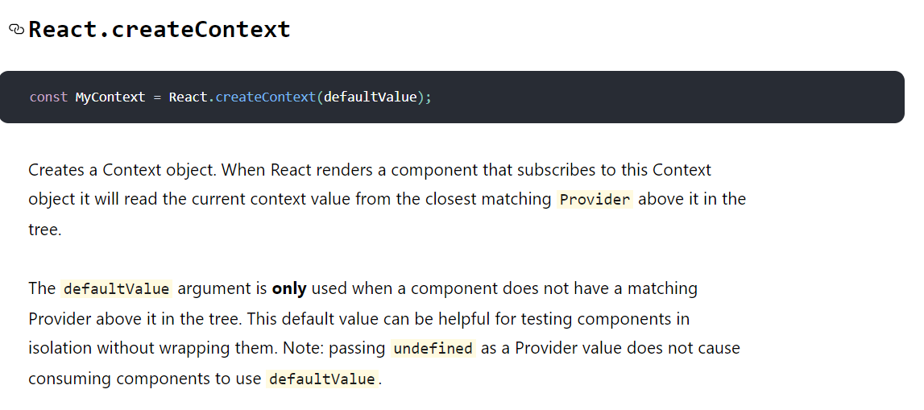

To study about how reducers work :-

[https://www.smashingmagazine.com/2020/12/how-redux-reducers-work/#:~:text=payload%20which%20is%20the%20movie,input%20and%20returns%20the%20fetchMovieReducer%20.](https://www.smashingmagazine.com/2020/12/how-redux-reducers-work/%23:~:text=payload%20which%20is%20the%20movie,input%20and%20returns%20the%20fetchMovieReducer%20.)

The useRef Hook allows you to persist values between renders.

It can be used to store a mutable value that does not cause a re-render when updated.

It can be used to access a DOM element directly.